**Module 7: Portfolio Milestone**

**Final Research Paper**

Marcella Hovseth

Colorado State University Global

MIS81: Capstone - Business Intelligence

Dr. Orenthio Goodwin

May 8, 2022

**Module 7: Portfolio Milestone: Final Research Paper**

**Abstract**

Population health is a synthesis of physical, mental, and social well-being. The COVID 19 pandemic has had a substantial detrimental impact on these determinants of health. In particular, the need to make adaptations to stop the spread of the virus set in motion events that crippled the United States labor market as there has been a collective reassessment of priorities among the U.S. labor force. Employees have resigned in record numbers and employers across all industries are struggling to fill position vacancies. The strain on the labor market caused employers to raise wages an average of 4.3% and provide hiring/referral bonuses. This triggered action from the Federal Reserve and the inflation rate as of February 2022 stood at 7.9%. This economic impact has added to the previously existing barriers to population health. This quantitative study investigated factors that contribute to employee churn (turnover). Historical data obtained from an open source were analyzed to gain insight into employee churn. The analysis shows a need to focus on employee retention and further investigate more recent causes of employee churn. Stabilizing the labor market will aid in stabilizing the economy which is necessary to improve population health.

**Keywords:** population health, labor shortage, employee churn, economic impact

**Module 7: Portfolio Milestone: Final Research Paper**

**Introduction**

COVID 19 was declared to be a pandemic by the World Health Organization (WHO) on March 11, 2020 (CDC Museum, 2022). Two years have passed since the declaration of the pandemic and COVID 19 is beginning a transition to an endemic phase which will take years to fully achieve (Antia & Halloran, 2021). The pandemic resulted in global changes and adaptations that had to be made at an unprecedented rate. The magnitude of the pandemic created a disturbance whose effect has seemingly touched every facet of our existence.

Efforts to contain the pandemic resulted in a shift to the status quo. Individuals had to make changes to their lifestyles and organizations had to adapt operations. Because of efforts to contain the pandemic the national unemployment rate increased while vacancy applications decreased (Marinescu et al., 2021). As the pandemic has worn on, there has been a collective reassessment of priorities that led to what came to be known as *The Great Resignation* (TGR) (Geisler, 2021).

Anthony Klotz is credited with coining the phrase and suggests that TGR is partially being driven by a repressed need for change that was exacerbated by the pandemic (Geisler, 2021). Geisler (2021) notes that in June of 2021, nearly 4 million Americans resigned from their place of employment. There has been a collective reassessment of priorities. Estimates state that nearly 48% of workers are contemplating or actively looking for a new job (Geisler, 2021). As the nation shifts out of crisis mode, there is a need to address the aftermath and impact on the national job market. The impact of the pandemic will take a substantial amount of analysis to fully understand.

**Problems**

The pandemic and TGR have had a far-reaching impact. In addition to an unprecedented national loss of life, the pandemic has also notably impacted the nation’s population health and economy (Rigby, 2021). The World Health Organization (WHO) identifies population health as a synthesis of physical, mental, and social well-being (Shi & Singh, 2019). Employment, income, and wealth are critical health determinants and each of these facets of well-being has been endangered by the pandemic.

***Population Health Impact***

This author has personally witnessed some of the challenges that have been created by employee churn in the healthcare industry. Staffing shortages have exacerbated employee burnout, caused delays in care, and resulted in unit/equipment closure due to lack of staff (Wilson, 2021), and patient dissatisfaction. On September 9, 2021, a former pediatric organization that this author worked for announced the need to close emergency and urgent care locations due to critical staffing concerns.

***Employee Turnover & Economic Impact***

Marinescu et al. (2021) noted an increase in open positions occurring across many industries. Organizations are experiencing staffing shortages that are detrimental to the organizations, employees (Jagangac et al., 2020), and their customers. The current climate of the labor market dictates that organizations must do more with less human resources. Filling staff vacancies and reducing employee churn has become paramount for organizational longevity.

Before the pandemic, Muehlemann & Strupler Leiser (2018) noted that the average cost of successfully hiring skilled workers averaged approximately 25% of a position’s annual salary. Muehlemann & Strupler Leiser (2018) explained that the cost included candidate selection, training costs, and reduced productivity resulting from informal training. The labor shortage caused by the pandemic has resulted in many organizations raising wages, offering internal referral bonuses, and offering hiring bonuses (Choudhary, 2021).

Choudhary (2021) correctly posited in his article that the increased wages would result in action from the Federal Reserve that would, in turn, raise the rate of inflation. In September 2021, Choudhary noted that the average increase in hourly earnings rose 4.3% (Choudhary, 2021). Trading Economics (n.d.) is currently reporting an annual 7.9% inflation rate as of February 2022 and is noting that the war in Ukraine could result in elevated inflation rates. This is unsustainable for both employers and the population.

**Objectives**

The Covid-19 pandemic set in motion events that will have long-lasting impacts on the national population’s health and economy. Stabilizing the labor market can have a far-reaching impact. Stabilizing the labor market has the potential to also assist in stabilizing and improving the national economy. The residual impact would be to improve population health.

The current employment climate, resulting from the pandemic, has made it increasingly apparent that organizations need to be able to do more with less human resources. Organizations must find a way to drastically reduce employee churn. Raman et al. (2018) note that analytics should also be employed to analyze employee data. Reviewing data from external sources such as Indeed or Glassdoor may provide more accurate data than internal exit interviews and thus improve actionable insight (Sainju et al., 2021).

Organizations that can leverage employee employment data and utilize it to quickly adapt to attract/retain employees will fare better than organizations that do not. As the purpose of research is to facilitate situation improvement (O’Leary, 2021), the objective of this research in this paper aims to gain insight into factors that contribute to employee turnover (churn). The research will also strive to understand how employee retention rates can be increased.

**Study Overview**

The employee turnover dataset was obtained from the was obtained from Louisville (KY) Metro Open Data page ("Turnover," 2021). The dataset contains the count of employees that left the Metro Government each month spanning 2011 to 2018. The turnover dataset was modified for analysis and converted to the churn dataset. The churn dataset contains 8,441 observations of 13 variables.

The study aims to provide insight into employee churn. Attracting and retaining employees has become paramount for organizations. It is well recognized that gaining insight as to the warning signs of employee churn can help organizations retain employees. This is of particular importance given the state of the current labor market, economy, and population health.

**Research Questions and Hypothesis**

The target variable for analysis will be CHURN which is defined as employees that left voluntarily. The preliminary questions and hypotheses for the research project are shown in Figure 1. Additional questions may be added to the research as analysis is conducted. The desire is that the results of hypothesis testing will provide insight into the factors that contribute to employee churn. Identifying contributing factors will present an opportunity for restorative measures to help reduce employee churn.

Figure 1

*Research questions and hypotheses.*

**Literature Review**

This study focuses on the effect of the COVID 19 pandemic on the United States (U.S) population health. Specifically, the effect of the pandemic on employment and the economy are explored as they relate to population health. The hope is that researching to better understand the impact of the pandemic in these areas will aid in understanding how stabilizing the labor market may in turn help improve population health. To that end, literature was reviewed to further explore these topics (O’Leary, 2021).

**COVID 19**

Washington State holds the distinction of having the first CDC confirmed case of COVID 19 found in the U.S. (CDC Museum, 2022). Covid 19 was officially declared a global pandemic on 3/11/2020 by the World Health Organization (CDC Museum, 2022). Mitigation policies were implemented in the U.S. that were not significantly effective in preventing or controlling the transmission of COVID 19 (Chen et al., 2021). The continued underinvestment in public health was exacerbated by the pandemic and has put the U.S. population at greater risk (Maani & Galea, 2020).

**U.S. Labor Force**

The U.S. employment market was already experiencing a repressed need for change before the onset of the pandemic (Geisler, 2021). Efforts to contain the pandemic resulted in temporary furloughs and layoffs which left more than 4 million Americans out of work for 6 months or more (Sharone,2021). Rigby (2021) notes that these changes to the labor market can have long-term implications. Marinescu et al. (2021) note an increase in open positions across industries.

On February 22, 2021, the official unemployment rate was 3.6% but the Federal Reserve and Department of the Treasury estimated that the actual rate was closer to 10% as many of the unemployed are permanently leaving the labor force (Brenner, 2021). The workforce has reassessed its priorities and is pragmatically assessing its options (Geisler, 2021).

**Economic Impact**

The federal government allocated an excess of $3 trillion to mitigate the impacts of COVID-19 (Han et al., 2020). Despite these efforts, Hackney & Friesner (2021) indicate that the pandemic contributed to increased consumer bankruptcies in 2020. The U.S. gross domestic product (GDP) saw a 9.5 percent reduction in the third quarter of 2020 (Hoffman, 2020). As of February 2022, the annual inflation rate is 7.9% (Trading Economics, n.d.) yet the average increase in hourly earnings rose 4.3% in 2021 (Choudhary, 2021). Food insecurity which spiked at the onset of the pandemic has remained nearly four times higher than pre-pandemic levels (Rogers et al., 2021).

**Population Health**

Health status has historically been unevenly distributed in the U.S. demonstrated by lower life expectancies among the poorest Americans (Maani & Galea, 2020). A further reduced life expectancy for minority groups has been noted by CDC (Brenner, 2021). Pandemic prevention measures altered the population’s food consumption and exercise behaviors, limited access to nutritious food, and overall quality of life (Rogers et al.,2021).

Psychologically, population segments have been more exposed to apprehension, feelings of depression, and stress resulting from trauma (Saladino et al., 2020). Young adults and children are at higher risk of developing anxiety while health care workers are at higher risk of developing mental and physical health issues most seen following catastrophic situations (Saladino et al., 2020). Understanding the long-term impact of the disruptions in care caused by the COVID 19 pandemic will require further research to create mitigation and long-term recovery strategies (Papautsky et al., 2020). The pandemic is likely to have extended repercussions as it has impacted income, employment, and wealth which are determinants of health (Rigby, 2021).

**Research and Design**

**Methodology**

SAS Studio will be used to conduct the quantitative data analysis for this research project. Summary and descriptive statistics will be visualized in tables to provide an overview of the dataset. Histograms will be created with kernel and normal curves to depict the variable range. Box plots will be used to assess the initial variable distribution and identify outliers in the dataset. Correlation graphs may also be used to visualize the linear association of the dataset variables which will aid in the final selection of model variables. Publicly available data were obtained from the

**Methods**

The turnover dataset, turnover.csv, was obtained from Louisville (KY) Metro Open Data page ("Turnover," 2021). The turnover dataset has 8,382 observations of 18 variables. The data ranges from 2011 to 2018 and shows the number of employees that have left the Kentucky Metro Government each month. The dataset was preprocessed in preparation for analysis and renamed churn. The cardinality of the turnover dataset was mixed; rows containing department summaries were removed and the cardinality was corrected to one row per employee whose employment ended. Derived variables %LEFT, REHIRE and the target variable CHURN were created and included in the churn dataset. The churn dataset has 8,441 observations of 13 variables. The data definitions for the churn dataset are shown in Figure 2.

**Figure 2**

*****Churn dataset data definitions.*

**Data Analysis**

SAS Studio will be used to conduct the preliminary data analysis for this research project. Summary and descriptive statistics will be visualized in tables to provide an overview of the dataset. Histograms will be created with kernel and normal curves to depict the variable range. Box plots will be used to assess the initial variable distribution and identify outliers in the dataset. Correlation graphs may also be used to visualize the linear association of the dataset variables which will aid in the final selection of model variables.

Hypotheses will be proven/disproven by using t-tests. T-Test results may be visualized in either table and/or graph format for the final research paper. Bar charts will be used to show the variable contribution to employee turnover once the analysis is completed. PowerBI may be used to visualize analysis findings. The proposed data analysis tools for the research paper are shown in Figure 3. Figure 3 also explains how and why the selected tools intend to be used.

Figure 3

*Analysis tools and reasoning*

**Ethical Considerations**

The original turnover dataset contained the variables AGE_GROUP_AT_DEPARTURE, ETHNIC_GROUP, and GENDER. These variables were removed as they are associated with a potential bias (Sajin, 2018) against protected classes. The derived variables %LEFT, REHIRE and CHURN were created and included in the data to create the target variable (CHURN) and to provide objective data free of bias for analysis.

Organizations can collect a large amount of data about their employees. It is imperative that the data is ethically collected, secured, and used. Employees should be made aware that data is being collected and its purpose. Providing a brief policy explanation (in plain English) to employees would increase the likelihood of employees reading it.

**Limitations**

Personal access to a dataset was limited so a secondary dataset was procured (O’Leary, 2021). The existing dataset was able to provide some insight as to the seasonality of involuntary turnover, but it lacked variables that may help identify the motivation behind the voluntary resignations. This may be because the turnover dataset originally contained summary data. The ideal scenario would be to obtain a dataset that includes post-pandemic data to provide clearer insight regarding the current reasons for employee turnover. Variables that indicate things that impact employee work-life balance should likewise be collected (e.g., commute distance, remote or on-site, benefit status).

**Findings**

**Dataset Statistics and Tests**

The churn dataset was evaluated using SAS Studio. Summary statistics were obtained using the CHURN variable as a classification variable. Statistics reviewed for the variables included the arithmetic mean, standard deviation, minimum/maximum values, and median values. The number of observations for each classification and variable was obtained as was noted. The number of missing variables was also reviewed to verify data completeness.

Figure 4 shows the summary statistics for the churn dataset. The Pearson correlations to the CHURN variable were reviewed for the EMP TYPE, YEARS, REHIRE, DEPT EMPS, EMP, and MONTH variables are shown in Figure 5.

**Figure 4**

*Summary statistics for churn dataset.*

**Figure 5**

*Pearson correlation coefficients*

Further analysis with t-Tests was conducted to answer the business questions and determine if the findings were statistically significant. The results of the t-Tests (questions 1-3) and their corresponding business question numbers (displayed in red) are shown in Figure 6. There were 35 different departments represented in the churn dataset, so the churn was graphed for visual comparison of equality (question 4).

Figure 6

*Hypotheses t-Test results.*

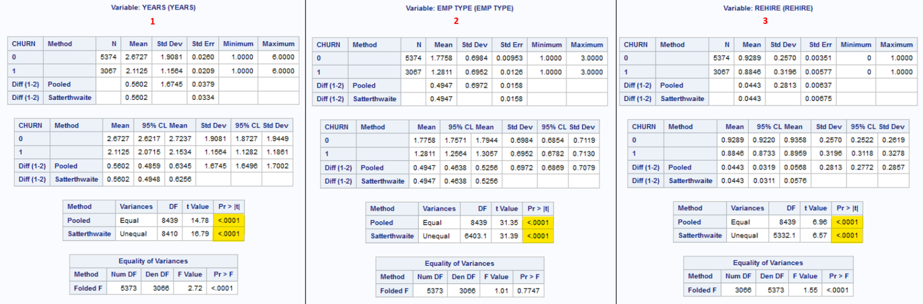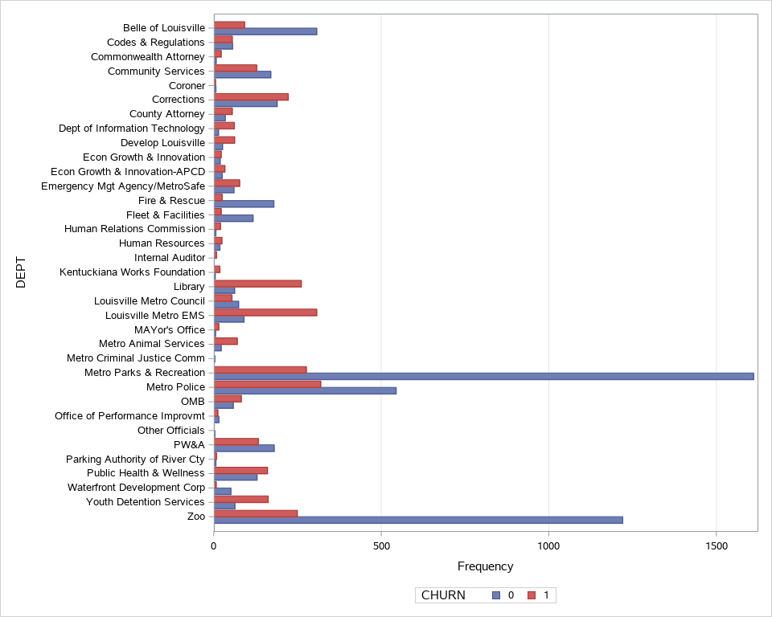

4

Both multiple linear regression and multiple predictive regression models were developed to determine the dataset’s ability to identify employees with an imminent propensity to churn. Based on root mean square error (RMSE), the linear regression model without model selection (RMSE 0.07984) outperformed the multiple regression model with stepwise selection (RMSE 0.07992). The linear regression model and model fit are shown in Figure 7

**Figure 7**

*Predictive regression model results and model fit plot.*

**Analysis**

It was interesting to note that of the 8,441 employees that left the organization, 36.3% left voluntarily (churned) while the majority (63.7%) were involuntarily let go as they were seasonal and temporary employees. The mean of the REHIRE variable for both classifications indicates that most of the employees the leave are eligible for rehire. It was also noted that July and June are the months with the greatest turnover. EMP TYPE, YEARS, and MONTH are the stronger indicators of churn.

The p-value for Pr >|t| results are highlighted in Figure 6 for the two-tailed t-Tests. At the 95% confidence level, the p-values (0.0001) indicate that the null hypothesis is accepted for questions 1, 2, and 3. A visible inspection of the churn by the department indicates that the null hypothesis should be rejected for 4. The results of business question 3 were of particular interest as was the fact that 63.7% of the churned employees were involuntarily terminated. It makes more sense, given the cost of hiring/training employees and the current labor market, to increase efforts to retain employees. Additional variables (e.g. commute distance, work-life balance) should be collected to help identify factors that contribute to employee churn.

**Conclusion**

The Covid-19 pandemic will have enduring effects on the nation’s population health and economy. Identifying factors that contribute to employee turnover will allow organizations to abate it. As more recent data becomes available, additional analysis will need to be conducted. Identifying and responding to emerging contributors to voluntary employee turnover will aid in stabilizing the employment market and ultimately can improve the nation’s economic and population health.

**Recommendations for Future Research**

The current employment climate, resulting from the pandemic, has made it increasingly apparent that organizations need to be able to do more with less human resources. Organizations need to also find a way to retain employees. Data analytics can be applied to current work processed to streamline them. The hope would be for process improvement efforts to mitigate employee burnout which could decrease employee turnover.

Additional research using predictive analytics (Raman et al., 2018) should also be employed to further analyze employee data. Exit interviews for resigning employees could help collect data as to the factors that contributed to the employee’s decision to leave an organization. The data from exit interviews, however, can be inaccurate as employee responses may not be as candid or actionable. Looking at external sources such as Indeed or Glassdoor may provide more accurate data and thus improve actionable insight (Sainju et al., 2021).

Another avenue that organizations could explore would be flexible work arrangements (Choi, 2019). Organizations that can leverage employee data and employ it to adapt quickly to attract/retain employees will survive the coming years. Organizations that do not, will not be as fortunate.

**References**

Antia, R., & Halloran, M. E. (2021). Transition to endemicity: Understanding COVID-19. Immunity, 54(10), 2172-2176. <https://doi.org/10.1016/j.immuni.2021.09.019>

Brenner, M. H. (2021). Unemployment, bankruptcies, and deaths from multiple causes in the COVID-19 recession compared with the 2000‒2018 Great Recession impact. American Journal of Public Health, 111(11), 1950-1959. <https://doi.org/10.2105/ajph.2021.306490>

CDC Museum. (2022, January 5). CDC Museum COVID-19 timeline. Centers for Disease Control and Prevention | CDC. <https://www.cdc.gov/museum/timeline/covid19.html>

Chen, H., Shi, L., Zhang, Y., Wang, X., Jiao, J., Yang, M., & Sun, G. (2021). Response to the COVID-19 pandemic: Comparison of strategies in six countries. Frontiers in Public Health, 9. <https://doi.org/10.3389/fpubh.2021.708496>

Choi, S. (2019). Flexible work arrangements and employee retention: A longitudinal analysis of the federal workforces. Public Personnel Management, 49(3), 470-495. <https://doi.org/10.1177/0091026019886340>

Choudhary, V. (2021, September 24). US hiring surges as COVID benefits expire, supply chain hit bites; Wage inflation in focus. TheStreet. <https://www.thestreet.com/investing/us-hiring-surges-as-covid-benefits-expire-supply-chain-hit-bites>

Geisler, J. (2021). The Great Resignation: Reality or myth? HFM (Healthcare Financial Management), 75(7), 44-45.

Han, J., Meyer, B. D., & Sullivan, J. X. (2020). Income and poverty in the COVID-19 pandemic. Brookings Papers on Economic Activity, 85. <https://doi.org/10.3386/w27729>

Hoffman, F. (2021). National security in the post-pandemic era. Orbis, 65(1), 17-45. <https://doi.org/10.1016/j.orbis.2020.11.002>

**References (continued)**

Jagangac, J., Gavric, T., & Obhodas, I. (2020). Effects of work stress and job satisfaction on employee retention: A model of retention strategies. International Journal of Sales, Retailing & Marketing, 9(2), 38-50.

Maani, N., & Galea, S. (2020). COVID‐19 and underinvestment in the health of the US population. The Milbank Quarterly, 98(2), 239-249. <https://doi.org/10.1111/1468-0009.12462>

Marinescu, I., Skandalis, D., & Zhao, D. (2021). The impact of the federal pandemic unemployment compensation on job search and vacancy creation. Journal of Public Economics, 200, N.PAG. <https://doi.org/10.3386/w28567>

Muehlemann, S., & Strupler Leiser, M. (2018). Hiring costs and labor market tightness. Labour Economics, 52, 122-131. <https://doi.org/10.1016/j.labeco.2018.04.010>

O′Leary, Z. (2021). The essential guide to doing your research project (4th ed.). SAGE.

Papautsky, E. L., Rice, D. R., Ghoneima, H., McKowen, A. L., Anderson, N., Wootton, A. R., & Veldhuis, C. (2020). Characterizing health care delays and interruptions in the United States during the COVID-19 pandemic: Internet-based, cross-sectional survey study (Preprint). <https://doi.org/10.2196/preprints.25446>

Raman, R., Bhattacharya, S., & Pramod, D. (2018). Predict employee attrition by using predictive analytics. Benchmarking: An International Journal, 26(1), 2-18. <https://doi.org/10.1108/bij-03-2018-0083>

Rigby, E. (2021). The COVID-19 economy, unemployment insurance, and population health. JAMA Network Open, 4(1), e2035955. <https://doi.org/10.1001/jamanetworkopen.2020.35955>

**References (continued)**

Rogers, A. M., Lauren, B. N., Woo Baidal, J. A., Ozanne, E. M., & Hur, C. (2021). Persistent effects of the COVID-19 pandemic on diet, exercise, risk for food insecurity, and quality of life: A longitudinal study among U.S. adults. Appetite, 167, 105639. <https://doi.org/10.1016/j.appet.2021.105639>

Saladino, V., Algeri, D., & Auriemma, V. (2020). The psychological and social impact of COVID-19: New perspectives of well-being. Frontiers in Psychology, 11. <https://doi.org/10.3389/fpsyg.2020.577684>

Sainju, B., Hartwell, C., & Edwards, J. (2021). Job satisfaction and employee turnover determinants in fortune 50 companies: Insights from employee reviews from Indeed.com. Decision Support Systems, 148, 113582. <https://doi.org/10.1016/j.dss.2021.113582>

Sharone, O. (2021). A crisis of long-term unemployment is looming in the U.S. Harvard Business Review Digital Articles, 1-12.

Shi, & Singh, D. A. (2019). Delivering health care in America (7th ed.). Jones & Bartlett Learning Trading Economics. (n.d.). United States inflation rate | 1914-2021 data | 2022-2023 forecast | Calendar. TRADING ECONOMICS | 20 million INDICATORS FROM 196 COUNTRIES. <https://tradingeconomics.com/united-states/inflation-cpi>

Trading Economics. (n.d.). United States inflation rate | 1914-2021 data | 2022-2023 forecast | Calendar. TRADING ECONOMICS | 20 million INDICATORS FROM 196 COUNTRIES. <https://tradingeconomics.com/united-states/inflation-cpi>

Turnover. (n.d.). Louisville Metro Open Data. <https://data.louisvilleky.gov/dataset/turnover>

**References (continued)**

Wilson, C. (2021). Heart patients facing surgery cancellations as staff shortages lead to theatre closure. The Herald (Glasgow, Scotland). <https://bi-gale-com.csuglobal.idm.oclc.org/essentials/article/GALE|A683840971/deb7d8158f83b93ade45451a32ced606?u=colstglobal>